**CP Club 365 Days Challenge**

**Programming language – C++**

**Problem Statement**

<https://www.codechef.com/DSAPREP_01/problems/COLOR8TEST>

**Your Code**:

// 0x81Day of 0x365Days challenge

// VEDANT BHARAD

// 6-1-2023

#include <iostream>

using namespace std;

int main() {

    // your code goes here

    int t;

    cin>>t;

    while(t--)

    {

        long long int n,x1,x2,x3,x4,x5,x6;

        cin>>n>>x1>>x2>>x3>>x4>>x5>>x6;

        long long sum=x1+x2+x3+x4+x5+x6;

        int x=n/2;

        if(n%2==0)

            cout<<sum*x<<endl;

        else

            cout<<sum*(x+1)<<endl;

    }

    return 0;

}

**Output (Screen Shot)**:

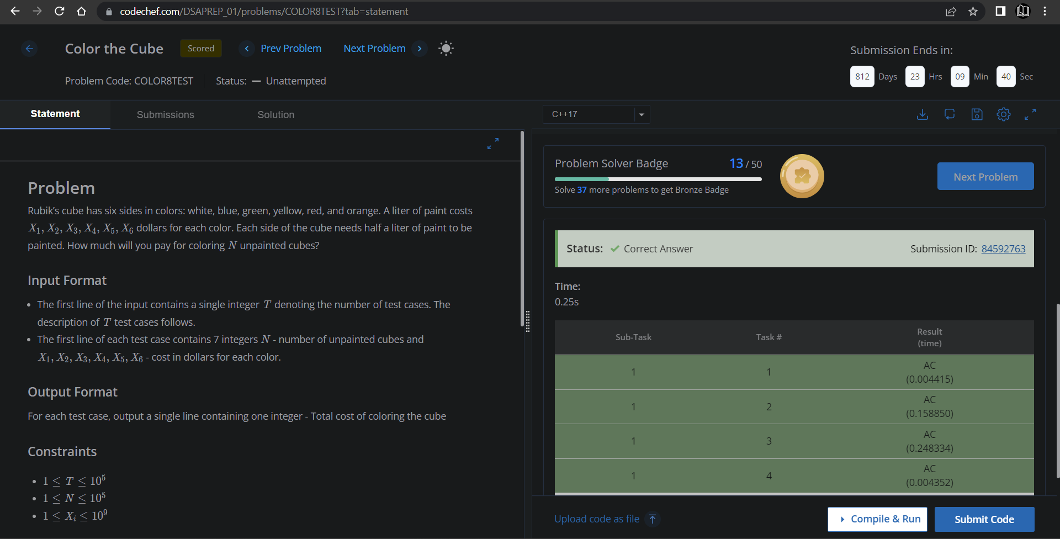

**Understanding about problem:**

* In this task there are N ,X1,X2,X3,X4,X5 and X6
* In this task I need to return int which is sum of X1,X2,X3,X4,X5 and X6 if N is even return sum*(n/2) else return sum*((n/2)+1).

Note: If you can't understand the problem, feel free to contact us and we'll help you. Please don't copy and paste from anywhere.

ALL THE BEST

Team CP Club